Integrated Science – 12 General Integrated Science

**Assessment Type:** Test

**Task Weighting :** 1%

**Name :**

Biodiversity and Threats to Biodiversity Test

Important Information for Students

1. This is a closed-book assessment (no notes are allowed)
2. The time allowed to complete the test is 30 minutes.
3. Circle the correct answer of each question in the Multiple Choice section
4. Write your answers to the Short Answer section in space provided.

[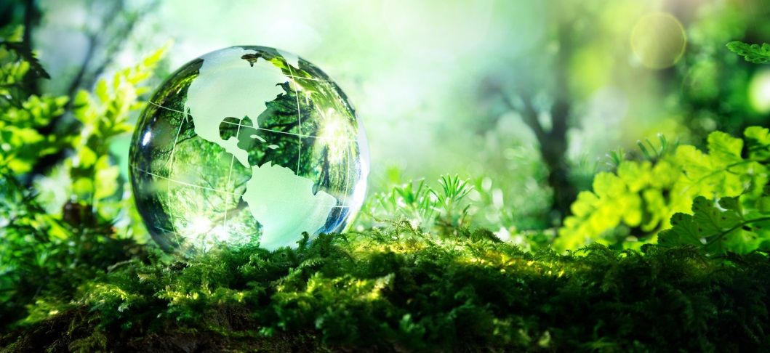](http://www.google.com.au/url?sa=i&rct=j&q=&esrc=s&source=images&cd=&cad=rja&uact=8&ved=2ahUKEwiL6vH-6O3cAhWBxbwKHWJpD68QjRx6BAgBEAU&url=http://scientifist.com/biodiversity-predicts-trillion-species/&psig=AOvVaw0m48K-Fw-_s4i5waMr-KCz&ust=1534379968164186)

1. Which of the following consists only of *abiotic* factors? (1 mark)
2. Light, predators, producers, gases
3. Collaborators, producers, prey, parasites
4. Gases, light, pressure, competitors
5. Temperature, climate, sunlight, acidity
6. Which of the following would show the greatest temperature variation in one day? (1 mark)
7. A fast flowing river.
8. A small pond.
9. A lake.
10. An ocean.
11. List *four* examples of biotic factors (4 marks)

__________________________________________________________________________________________________________________________________________

1. Define Biodiversity. (1 Mark)

_______________________________________________________________________________________________________________________________________________________________________________________________________________

1. Explain how *increasing* the *amount* of the following abiotic/ biotic factors would affect biodiversity. (4 Marks)
2. Predators

_______________________________________________________________________________________________________________________________________________________________________________________________________________________________________________________________________________________________________________________________________________

1. Water

_______________________________________________________________________________________________________________________________________________________________________________________________________________________________________________________________________________________________________________________________________________

1. The cassowary a bird that is the main seed dispersal agent in the rainforests of northern Queensland. It consumes the fruit from plants and drops the seeds throughout the rainforest when it defecates. Why should humans protect the cassowary? (2 Marks)

_________________________________________________________________________________________________________________________________________________________________________________________________________________________________________________________________________________________________________________________________________________________

1. Describe the traits of the below ecosystems (4 marks)
   1. Tropical and subtropical grasslands, savannas and shrublands

____________________________________________________________________________________________________________________________________________________________________________________________________________________________________________________________________________________

* 1. Deserts and xeric shrublands

____________________________________________________________________________________________________________________________________________________________________________________________________________________________________________________________________________________

1. Explain why Tasmania has taller trees, and more of them than central Australia does (2 marks)

____________________________________________________________________________________________________________________________________________________________________________________________________________________________________________________________________________________

1. Freshwater river temperatures in Australia can be aﬀected by ‘cold water pollution’. This is due to the release of cold waters from damming upstream. The release of cold waters threaten the survival of warm-water aquatic species, such as the silver perch (Bidyanus bidyanus). The rapid decline of silver perch along the Murray-Darling Rivers in New South Wales has resulted in the fish being listed as a vulnerable species.

An investigation was undertaken on the silver perch and its tolerance to water temperature. Results are shown in the table below. The table is a combination of a number of experiments showing the tolerance as a percentage of fish you would expect to find at a particular temperature.

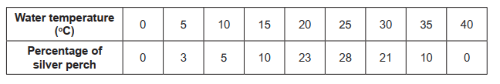

1. Identify the independent and dependant variable in this study (2 marks)

____________________________________________________________________________________________________________________________________________________________________________________________________________________________________________________________________________________

1. Use the table to describe the relationship between water temperature and silver perch populations (3 marks)

____________________________________________________________________________________________________________________________________________________________________________________________________________________________________________________________________________________

/24 %